Superstore Sales Analysis Dashboard

- Project Overview: This project analyzes sales, profit, customer behavior, and regional performance using the US Superstore dataset (2014–2017). The goal is to identify business opportunities, profitable categories, loss-making products, and regional performance trends.

- Tools Used:
- Excel (Data Cleaning & Pivot Analysis)
- Power BI (Dashboard & Visualization)

- Dataset Information:
- Total Records: 9,994
- Time Period: 2014–2017
- Regions: West, East, Central, South
- Categories: Furniture, Office Supplies, Technology

- Project Objective: The objective of this project is to analyze sales performance, profitability, customer purchasing behavior, and regional trends using the US Superstore dataset. The analysis aims to identify profitable business areas, loss-making products, and opportunities for improving business performance through data-driven decision making.

- KPI Summary:
- Total Sales: $2.30M
- Total Profit: $286.40K
- Total Orders: 5,009
- Analysis Period: 2014 – 2017

- Key Findings:
- The West region generated the highest sales and profit among all regions.
- The South region recorded the lowest sales performance and requires business growth strategies.
- Technology was the most profitable category and contributed significantly to overall business profit.
- Furniture generated strong sales but comparatively lower profit.
- Tables and Bookcases were identified as loss-making sub-categories.
- Copiers and Phones were the most profitable sub-categories.
- Sales showed an increasing trend from 2014 to 2017, indicating business growth over time.

- Business Recommendations:
- Reduce excessive discounts on Tables and Bookcases to improve profitability.
- Increase focus on Technology products as they generate the highest profit.
- Investigate the Central region to identify factors affecting profit performance.
- Develop targeted marketing and sales strategies for the South region to improve sales growth.
- Introduce loyalty programs for top customers to increase customer retention and revenue.

- Conclusion: The Superstore Sales Analysis project successfully identified key business trends, profitable categories, high-value customers, and loss-making products. Through Excel-based analysis and an interactive Power BI dashboard, valuable business insights were generated to support data-driven decision making. The findings can help management improve profitability, optimize product strategy, and enhance regional sales performance.

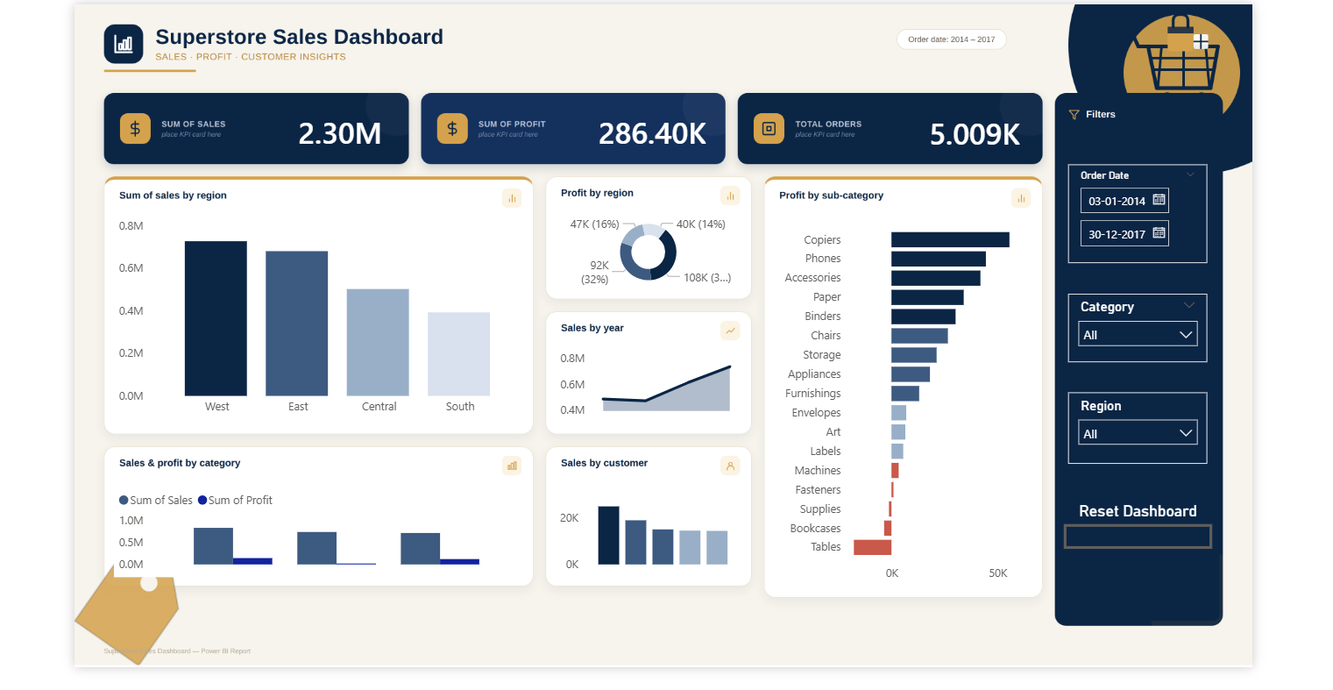
Superstore Sales Analysis Dashboard

